研究興趣
簡介:
研究蛋白質的表現與功能是後基因時代一個重要的生物醫學課題。由於增進檢測微量蛋白的靈敏性與含括性可以更全面有效地了解蛋白質表現差異，使得高靈敏性與高解析度的儀器因此蘊育而生。這些發展主要包括二維電泳技術(2D-gel electrophoresis)、iTRAQ、雷射介質輔助蛋白質譜儀技術(MALDI-MS)與液相層析串聯式質譜儀技術(LC-MS/MS)。二維電泳技術可將數千種細胞內之蛋白質予以分離，若進一步配合高靈敏度的差異性螢光標記(2D-DIGE, 2-dimensional differential gel electrophoresis) ，則可於一片二維電泳同時比較不同螢光標記樣品，並儘可能降低多次電泳時所造成的誤差(gel-to-gel variation)而可以對數千種已分離的蛋白進行精確的定量分析﹙詳見下圖﹚。雷射介質輔助蛋白質譜儀則可解析酵素分解所得之peptides 形成 peptide fingerprinting，配合資料庫蒐尋而鑑定出該未知蛋白質。此外，液相層析串聯式質譜儀可將液相層析所得之peptides進行序列分析及轉譯後修飾分析，並可對免疫沉澱後的蛋白複合體進行定性及定量分析。本實驗室研究興趣則以這些技術為基礎，應用於生物醫學相關課題。同時，本實驗室也將建立新的蛋白質體學定量分析技術列為重點發展方向之一。目前研究計劃方向如下：

- 發展定量蛋白質體學技術，來尋找癌症相關的 biomarkers。
- 發展細胞次胞器定量蛋白質體學，來探討相關疾病之研究。
- 發展氧化還原定量蛋白質體學技術，來探討氧化還原相關疾病(如Ischemia reperfusion) 之機制及治療進行探討。
- 利用蛋白質體學技術，探討果蠅腦蛋白質與記憶之關係。
- 癌症細胞抗藥性藥物蛋白質體學研究。
- 發展膜表面蛋白定量蛋白質體學技術，來尋找癌症相關的membrane biomarkers。
- 發展體液蛋白質體學技術，自血液及其他體液尋找癌症、糖尿病及遺傳疾病之biomarkers，作為診斷醫療之用。
- 發展幹細胞蛋白質體學技術，研究其表面蛋白質組成及尋找新的幹細胞生物標記分子。
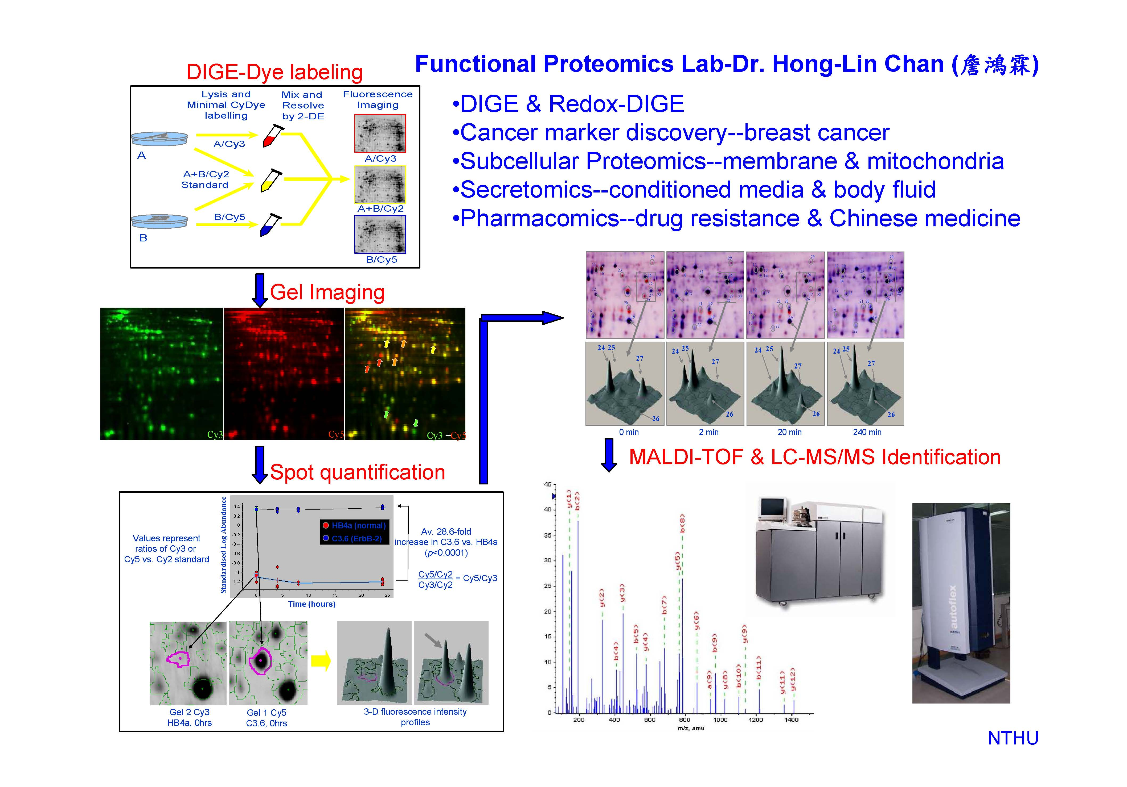

Research Interests
Introduction:
Two-dimensional-gel electrophoresis (2-DE) is an essential tool for proteomic study. It was used to separate thousands of proteins in complex biological samples enabling a global comparison of the expression and post-translational modification of proteins. Traditional 2-DE methodology work by comparing samples on separate gels, but because of gel-to-gel variation, this creates problems for the accurate quantitation of protein differences across multiple gels and samples. A recently developed technique, 2-dimensional difference gel electrophoresis (2D-DIGE), can compare protein expression levels between samples run on the same 2-DE gel by means of labelling samples with different fluorescent dyes, thus avoiding the gel-to-gel variations inherent to comparative gel analysis. Once the methodology has been established and validated, this technique will be used to compare the expression profiles of biological samples. Differentially expressed proteins detected in this manner, will be picked for identification by MALDI-TOF (matrix assisted laser desorption ionization-time of fly) mass spectrometry or by LC-MS/MS (liquid chromatograpy tadem mass spectrometry). Interesting biomarkers will be further analysed in biochemical and functional assays to assess their biological roles. In addition to protein quantification and identification via 2D-DIGE/mass spectrometry strategy, protein separation and analysis can also be done using non-gel based methods such as chromatographic separation coupled to LC-MS/MS mass spectrometric analysis. The benefits of this method are able to analyze post-translational modifications of proteins, detect of peptides derived from lower abundant proteins and analyze the protein complexes via ligand pulling down experiments. In conclusion, it is my aim to apply these state-of-art techniques in biomedical research. The figure demonstrates the gel-based proteomic quantitation, mass-spectrometry analysis, data validation and functional assay.

Current Projects:

- Develop plasma membrane proteomics to study cancer associated biomarkers.
- Develop organelle proteomics to study organelle related diseases.
- Phosphoproteomics approach to investigate the detail of the phosphorylation events associated with H2O2-induced oxidative stress.
- Using proteomics strategies to find out the mechanism of capsaicin and to evaluate its potentiality for cancer treatment.
- Using redox-proteomics strategies to elucidate ROS-induced tissue damages and develop it for the therapeutic application.
- Using proteomics strategies to study Fly brain proteome.
- Pharmacoproteomics to study the drug-resistance in cancer cells.
- Develop serum proteomics to discover diabetes and cancer-related biomarkers.
- Develop body fluid proteomics to discover inherent diseases-related biomarkers.
- Develop cancer stem cell proteomics to discover potential new stem cell surface markers.

